Nursing Home Transition (NHT) Resources

Table of Contents
Program Overview Module 1
NHT and Money Follows the Person (MFP) Eligibility Resources 1
Transition Planning Resources 1
Community HealthChoices (CHC) – Transportation 1
Housing Module 2
Section 811 Project Rental Assistance (PRA) Program 2
Home Maintenance Deduction Resources 2
Pennsylvania Caregiver Support Program / Family Caregiver Support Program (FCSP) 2
NHT Program for Providers Website 3
General Resource Links 4
Elder Resources 5
Resources for People with Disabilities 5
Emergency Preparedness and Recovery 6
Employment Resources 6
Housing Resources 7
Other Resources 8

Program Overview Module

NHT and Money Follows the Person (MFP) Eligibility Resources
Home and Community-Based Services (HCBS) Eligibility Form (PA-1768)
http://services.dpw.state.pa.us/oimpolicymanuals/ltc/PA_1768-Revised_Home_and_Community-Based_Service_(HCBS)_EligibilityIneligibilityChange_Form_(PA_1768).pdf
NHT Guidebook
https://www.pa.gov/content/dam/copapwp-pagov/en/dhs/documents/providers/providers/documents/nht-providers/NHT%20Guidebook.pdf

Transition Planning Resources
NHT Helpline: 1-800-833-5196
Email: Ra-pwnhtinfo@pa.gov
State NHT Team contact information:
- Rachel Sink (Primary contact), phone: 717-783-7378
- Brandy Green, phone: 717-783-7219

Community HealthChoices (CHC) – Transportation
CHC Transportation Fact Sheet
https://www.pa.gov/content/dam/copapwp-pagov/en/dhs/documents/healthchoices/hc-services/documents/Transportation.pdf

Housing Module

Section 811 Project Rental Assistance (PRA) Program
www.hudexchange.info/programs/811-pra/
SDHP is the statewide waitlist administrator for the 811 Project Rental Assistance Program (email: sdhp811@inglis.org) and provides training and technical assistance to service providers wishing to refer their participants to the program.

Home Maintenance Deduction Resources
https://www.pa.gov/content/dam/copapwp-pagov/en/dhs/documents/services/disabilities-aging/documents/alternatives_to_nursing-homes/NHT-Home%20Maintenanice%20Deduction.pdf

Pennsylvania Caregiver Support Program / Family Caregiver Support Program (FCSP)
https://www.pa.gov/en/agencies/aging/aging-programs-and-services/caregiver-support-program.html

NHT Program for Providers Website
www.pa.gov/en/agencies/dhs/resources/for-providers/ltc-providers/nht-providers.html
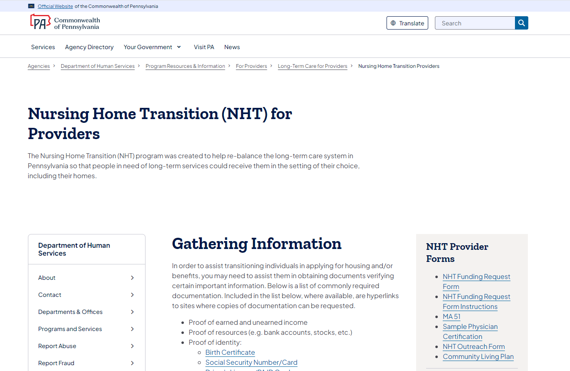

General Resource Links
Aging and Disability Resource Center (PA LINK to Resources)
https://www.pa.gov/en/agencies/aging/local-resources/pa-link-to-aging-and-disability-resources.html#.VyD5CHrD8kI
American Public Transportation Association
www.apta.com
Commonwealth of Pennsylvania Website
www.pa.gov
COMPASS (apply for benefits provided by human services programs)
https://www.compass.dhs.pa.gov/home/#/
Department of Human Services
https://www.pa.gov/en/agencies/dhs.html
NHT Program for Citizens
www.pa.gov/en/agencies/dhs/resources/aging-physical-disabilities/nursing-home-transition.html
Pennsylvania Housing Finance Agency (PHFA) Homeownership Programs
www.phfa.org/homeowners
PHFA Housing Services
www.phfa.org/mhp/serviceprovider
Pennsylvania Public Transportation Association
https://ppta.net/
Property Tax/Rent Rebate Program
https://www.pa.gov/en/agencies/revenue/incentives-credits-and-programs/ptrr.html
Social Security Administration
www.ssa.gov

Elder Resources
Pennsylvania Association of Area Agencies on Aging (P4A)
www.p4a.org
Pennsylvania Department of Aging
https://www.pa.gov/en/agencies/aging.html

Resources for People with Disabilities
Americans with Disabilities Act (ADA)
www.ada.gov
Autism – Paula Kluth’s Inclusion Rules
www.inclusionrules.com
National Association of the Deaf
www.nad.org
National Family Association for Deaf-Blind - Welcome
www.nfadb.org/
National Federation of the Blind
www.nfb.org
USA.gov – Federal government website for information on nationwide disability programs and services
www.usa.gov/disability-services
Disability Rights Pennsylvania
www.disabilityrightspa.org/
Harrisburg – 800-692-7443 (877-375-7139 TDD)
Philadelphia – 215-238-8070
Pittsburgh – 412-391-5225
Intellectual Disabilities Services
https://www.pa.gov/en/agencies/dhs/resources/intellectual-disabilities-autism/intellectual-disabilities-services.html
PA Council on Independent Living (PCIL)
www.thepcil.org
Severe Communication Disorders – Communication matrix for parents and professionals
www.communicationmatrix.org/
World Institute on Disability
www.wid.org/

Emergency Preparedness and Recovery
American Red Cross
www.redcross.org
Disaster Assistance
www.disasterassistance.gov
Federal Emergency Management Agency
www.fema.gov
Pennsylvania Emergency Management Agency
https://www.pa.gov/en/agencies/pema.html

Employment Resources
Job Search – PA CareerLink
www.pacareerlink.pa.gov/jponline/
PA Department of Labor and Industry – PA Office of Vocational Rehab (OVR)
https://www.pa.gov/en/agencies/dli/programs-services/disability-and-vocational-rehabilitation/vocational-rehabilitation.html
PA Medical Assistance for Workers with Disabilities
www.pa.gov/en/agencies/dhs/resources/medicaid/medicaid-workers-disabilities.html
Work Incentives Planning and Assistance
www.ssa.gov/work/WIPA.html

Housing Resources
Housing Alliance of Pennsylvania
www.housingalliancepa.org/
Local Housing Options Teams (LHOTs)
Currently, LHOT information is provided on the internet through several county-related websites. Doing an internet search will locate some of these resources.
PA Assistive Technology Foundation
www.patf.us/
Community Action Association of Pennsylvania
www.thecaap.org/
PA Housing Finance Agency
www.phfa.org/
PA Housing Search
www.pahousingsearch.com
PA Residential Owners Association (PROA)
https://proassoc.org/
Regional Housing Coordinator Program (RHCP) – Information & Referral Request
www.inglis.org/programs-and-services/inglis-community-services/self-determination-housing-of-pennsylvania-sdhp/regional-housing-coordinator-program/information-and-referral-request
Self-Determination Housing of Pennsylvania (SDHP)
www.inglis.org/programs-and-services/inglis-community-services/self-determination-housing-of-pennsylvania-sdhp
US Department of Agriculture
www.usda.gov
US Department of Housing and Urban Development (HUD)
www.hud.gov
HUD Exchange
www.hudexchange.info/
US Department of Veterans Affairs (VA)
www.va.gov
US Internal Revenue Service – Tax Highlights for Persons With Disabilities
www.irs.gov/publications/p907
PA Low-Income Home Energy Assistance Program (LIHEAP)
https://www.pa.gov/en/services/dhs/apply-for-the-low-income-home-energy-assistance-program-liheap.html
Pennsylvania Association of Housing and Redevelopment Agencies (PAHRA)
www.pahra.org/

Other Resources
Annual Credit Report
www.annualcreditreport.com
Commission on Accreditation of Rehabilitation Facilities (CARF)
www.carf.org/home/
Consumer Credit Counseling Services (CCCS)
https://credit.org/credit-services/consumer-credit-counseling
Federal Trade Commission – Spam
https://consumer.ftc.gov/articles/how-get-less-spam-your-email
Government Mortgage Help
https://home.treasury.gov/policy-issues/coronavirus/assistance-for-state-local-and-tribal-governments/homeowner-assistance-fund
Help in PA – Resources for Your Family's Health
https://www.pa.gov/en/agencies/health/programs/healthy-living/help-in-pa.html
The Joint Commission
www.jointcommission.org/
National Center for Cultural Competence
https://nccc.georgetown.edu/
National “Do Not Call” Registry
www.donotcall.gov/

U.S. Access Board – Advancing Full Access and Inclusion for All
www.access-board.gov/
Obtaining a Photo Identification Card
www.dmv.pa.gov/Driver-Services/Photo-ID2/Pages/Get%20An%20ID.aspx
Pennsylvania ABLE Savings Program (PA ABLE)
www.paable.gov/benefits/?utm_medium=search&utm_source=google&utm_campaign=pa_able&utm_content=fy21
PA Department of Aging Ombudsman
https://www.pa.gov/services/aging/request-assistance-from-a-long-term-care-ombudsman.html
PA Department of Labor and Industry
https://www.pa.gov/en/agencies/dli.html
Pennsylvania Advocacy and Resources for Autism and Intellectual Disability
www.par.net/
Social Security Card Application
www.ssa.gov/online/ss-5fs.pdf
Request Military Service Records (DD Form 214)
www.archives.gov/veterans/military-service-records/
Veteran’s Benefits and Outreach
www.va.gov

