OLTL Service Coordination Resources

Table of Contents
Service Coordinator Training and Development Links 2
Service Coordinator Resources 3
Bulletins and Directives 11
DHS ListServs 11
Publications Search 12
Bulletin Search 13
Service Plan Bulletin 16
Participant Information Packet 17

Service Coordinator Training and Development Links
The 55 Pa. Code, Chapter 52.27 requires Service Coordinators to complete continuing education in specific categories. Service Coordinators and their supervisors should review the regulations and develop plans to complete and document training activities.
Boston University Center for Aging and Disability Education and Research (CADER)
https://thenetwork.bu.edu/cader/
Centers for Medicare and Medicaid Services (CMS)
www.cms.gov
DirectCourse
login.elsevierperformancemanager.com/systemlogin.aspx?virtualname=PA
Department of Human Services, Long-Term Care Services
dhs.pa.gov/Services/Disabilities-Aging/Pages/Long-Term-Care-Services.aspx
Home and Community Services Information System Learning Management System (HCSIS LMS) – The updated HCSIS guidebook is located in HCSIS LMS website under “my curriculum.”
www.hcsis.state.pa.us/HCSISLMS/pgm/asp/login/login.asp?refpage=/HCSISLMS/default.asp
Pennsylvania Homecare Association (PHA)
www.pahomecare.org
Pennsylvania Training and Technical Assistance Network (PATTAN)
www.pattan.net
Regulations for Service Coordinators and providers of long-term living home and community-based services are part of 55 Pa. Code, Chapter 52.
https://www.pacodeandbulletin.gov/Display/pacode?file=/secure/pacode/data/055/chapter52/chap52toc.html

Service Coordinator Resources

Resource | Description | Contact Information
211  www.pa211.org | To connect with resources in your community, get help with a utilities bill, housing assistance, after-school programs for kids, and more, dial 211 or text your zip code to 898-211. Specialists will listen to your needs and give you information on programs in your community that might be able to help. | Dial 211  Call 1-855-567-5341  211 Overview  www.pa211.org/211-overview
Area Agencies on Aging (AAAs) | Pennsylvania’s 52 AAAs are a great source of information for the issues and concerns affecting older people and their caregivers. Specific services at each AAA vary, but each offer a wide array of programs to help older Pennsylvanians and their families get the help and information they need. | Contact list of AAAs by county  www.aging.pa.gov/local-resources/Pages/AAA.aspx
COMPASS SSD  www.compass.state.pa.us/compass.web/EPProviderSearch/Pgm/EPWEL.aspx?prg=LTH | COMPASS Service and Support Directory is a search engine for participants, providers, and Service Coordination Entities to find qualified providers. | For additional consumer information, contact the Long-Term Living Helpline.  Phone: 866-286-3636
County Assistance Offices (CAOs) | Pennsylvania residents can seek assistance and a range of services for themselves and their families from professionally trained staff members at CAOs. | Contact list of CAOs by county  www.dhs.pa.gov/Services/Assistance/Pages/CAO-Contact.aspx
Department of Human Services (DHS)  www.dhs.pa.gov | The Department of Human Services consists of six executive level offices and eight different program offices. | DHS Feedback Form  https://www.dhs.pa.gov/contact/Pages/Feedback.aspx
Department of Military & Veterans Affairs (DMVA)  www.dmva.pa.gov | Pennsylvania's Department of Military and Veterans Affairs (DMVA) has a dual mission: to provide quality service to the Commonwealth’s veterans and their families, and to oversee and support the members of the Pennsylvania National Guard (PNG). | Contact list of DMVAs by county  www.dmva.pa.gov/veteransaffairs/Documents/Outreach-and-Reintegration/County_directors.pdf
Enterprise Incident Management System (EIM)  www.hhsapps.state.pa.us/eim | Web-based system that records, tracks, and manages incidences that occur to participants in the under 60 waivers. | For policy-related incident management questions, send an email to:  RA-OLTL_EIMimplement@pa.govI
Federal Emergency Management Agency (FEMA)  www.fema.gov | FEMA’s mission is helping people before, during and after disasters, and our guiding principles help us achieve it. | FEMA Helpline  1-800-621-3362
Fraud and Abuse Resource | Website and telephone numbers used to report fraud or abuse. | Bureau of Program Integrity  www.dhs.pa.gov/contact/DHS-Offices/Pages/OA-Bureau%20of%20Program%20Integrity.aspx  To report abuse, call:  844-DHS-TIPS (844-347-8477)
Home and Community Services Information System Learning Management System (HCSIS LMS)  www.hcsis.state.pa.us/HCSISLMS/pgm/asp/login/login.asp?refpage=/HCSISLMS/default.asp | The Home and Community Services Information System (HCSIS) is the Department of Human Services’ computer system used to improve the management of HCBS programs and Medical Assistance waivers for people under age 60. | HCSIS Frequently Asked Questions  www.hcsis.state.pa.us/hcsis-ssd/custom/HCSIS_FAQ.pdf  HCSIS Help Desk  Phone: 866-444-1264  Fax: 717-540-0960  Email: c-hhcsishd@pa.gov
Health Care/Medical Assistance (MA)  www.dhs.pa.gov/Services/Assistance/Pages/Medical-Assistance.aspx | Website that provides information on how to apply, what to do if an individual is not eligible, and types of care available. | For additional information, contact the Consumer Service Center for Health Care Coverage:  866-550-4355
Medicaid State Plan | The plan is not available online and the files are too large to email. Text searchable PDF files are available on a CD Rom. | OMAP - Bureau of Policy, Analysis, and Planning  PO Box 2675  Harrisburg, PA 17120  Attn: Regulations Coordinator
OLTL Bureau of Participant Operations | Waiver program specialists in the Bureau will address questions pertaining to participants and their service plans. | Phone: 800-757-5042
OLTL Bureau of Quality & Provider Management  www.dhs.pa.gov/providers/Providers/Pages/Quality.aspx | The BQPM Provider Assessment & Certification Resource Account inbox can be sent emails from providers who have questions or issues related to OLTL provider enrollment. Please note that this mailbox cannot be used to submit provider enrollment applications.  Hotline open to providers with questions related to Long-Term care service provision and OLTL waivers, enrollment, billing, etc. | Toll free: 1-800-932-0939  Mon – Fri, 9:00 am to 12:00 pm and 1:00 pm to 4:00 pm  Option 1: Provider Enrollment  Option 2: Billing and Claims  Option 3: Nursing Home Transition  Email:  mailto:RA-ProviderOperation@pa.gov  Email Enrollment section:  RA-HCBSEnProv@pa.gov  Fax: (717) 772-0965
OLTL Participant Helpline | Enrolled waiver participants can call with any concerns regarding their services. | Phone: 800-757-5042
PA Adult Day Services Association (PADSA)  www.padsa.org | PADSA is an organization of providers and individuals interested in the promotion of quality Adult Day Services in Pennsylvania. | Phone: 215-779-1010  PADSA Contact Form  www.padsa.org/contact
Pennsylvania Code  www.pacodeandbulletin.gov | 55 Pa. Code, Chapters 52 and 1101 | Pennsylvania Code Frequently Asked Questions  www.pacodeandbulletin.gov/Home/FAQ
PA Centers for Independent Living (CIL) | Assists in removing barriers and expanding independent living options available to people with disabilities and the elderly. | Contact List of CILs by county  pasilc.org/independent-living/find-a-cil-by-county
Pennsylvania Emergency Management Agency (PEMA) ReadyPA  www.ready.pa.gov | The Pennsylvania Emergency Management Agency (PEMA) helps communities and citizens mitigate against, prepare for, respond to, and recover from emergencies including natural disasters, acts of terrorism, or other human-made disasters. | Plan for Special Needs  www.ready.pa.gov/BePrepared/PlanSpecialNeeds/Pages/default.aspx
PA Independent Enrollment Broker (IEB)  www.paieb.com | Provides enrollment services for adult applicants with physical disabilities or are age 60 and over who are applying for Community HealthChoices (CHC), OBRA and Act 150. | PA IEB Helpline at 1-877-550-4227 (TTY: 711).
PA Link to Aging and Disability Resources  www.aging.pa.gov/local-resources/pa-link/Pages/default.aspx | Pennsylvania’s federal Aging and Disability Resource Center (ADRC) program is called the PA Link to Aging and Disability Resources. The PA Link is a network of long-term service and support (LTSS) agencies and providers that work together to streamline consumer access to services and programs. The PA Link facilitates referrals, provides training, and sponsors networking events for organizations in the LTSS network. | Providers can contact a regional representative.  Individuals can contact a local PA Link partner or the statewide call center.  Phone: 800-753-8827
Rehabilitation & Community Providers Association (RCPA)  www.paproviders.org | A forum for exchange of information/experience. Represents providers on legislative and administrative matters and serves as a point of contact with other related statewide organizations. | Phone: 717-364-3280  Fax: 717-364-3287  Email: info@paproviders.org  RCPA Contact Form  www.paproviders.org/contact
Pennsylvania Homecare Association (PHA)  www.pahomecare.org | The Pennsylvania Homecare Association is a state trade association representing more than 700 organizations that provide care and support to individuals in their own homes. PHA helps its members tackle everyday challenges. With a member-centered focus, the association champions efforts that range from advocating on behalf of patients and consumers, interpreting, and developing regulations and legislation to exploring needs and business strategies. | Phone: 800-382-1211 or  717-975-9448  Fax: 717-975-9456
PROMISe™ Internet Portal  https://promise.dpw.state.pa.us/portal/(S(04zqxc32gtwu1045ij2relex))/Default.aspx?alias=promise.dpw.state.pa.us/portal/provider&AspxAutoDetectCookieSupport=1 | PROMISe™ is the claims processing, provider enrollment, and user management information system. | PROMISe™ Provider Internet User Manual  https://promise.dpw.state.pa.us/promisehelp/manuals/PROMISeProviderInternetUserManual.pdf  To request training, send an email to: PROMISe.ProviderTraining@GainwellTechnologies.com
PROMISe™ Provider Handbooks and Billing Guides | DHS has a number of PROMISe™ handbooks and billing guides for all provider types. In addition, OLTL maintains a PROMISe™ Help Desk for providers. | PROMISe™ Provider Handbooks and Billing Guides  www.dhs.pa.gov/providers/PROMISe_Guides/Pages/PROMISe-Handbooks.aspx
Provider Assistance Center (PAC) | For provider questions on electronic claims and transaction submissions and the Provider Electronic Submission (PES) software. | Phone: 800-248-2152 or  717-975-4100
Waiver/Program Descriptions  www.dhs.pa.gov/Services/Disabilities-Aging/Pages/Alternatives-to-Nursing-Homes.aspx | List and description of waivers and programs | For additional information, contact the Office of Long-Term Living Helpline:  800-753-8827

Bulletins and Directives
OLTL and the Office of Medical Assistance Programs (OMAP) issue bulletins and directives that apply to Service Coordinators of HCBS. These documents contain operating procedures, clarifications, and explanations of existing regulations.

DHS ListServs
https://www.dhs.pa.gov/about/Pages/Listservs.aspx

To access from the DHS Homepage:
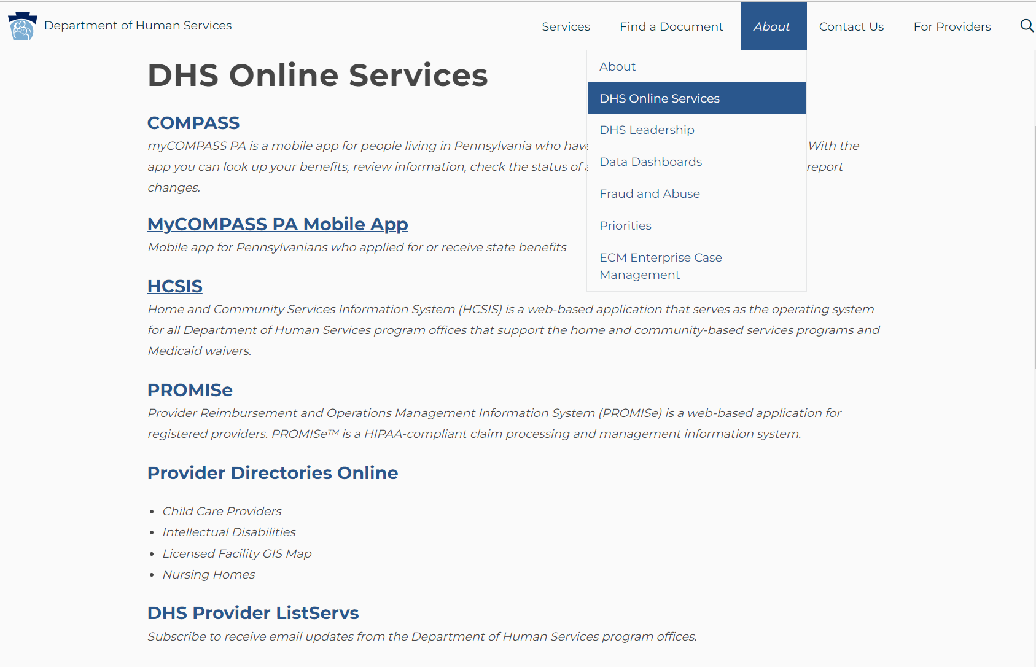
3
2
1

Publications Search
https://www.dhs.pa.gov/docs/Publications/Pages/default.aspx

To access from the DHS Homepage:
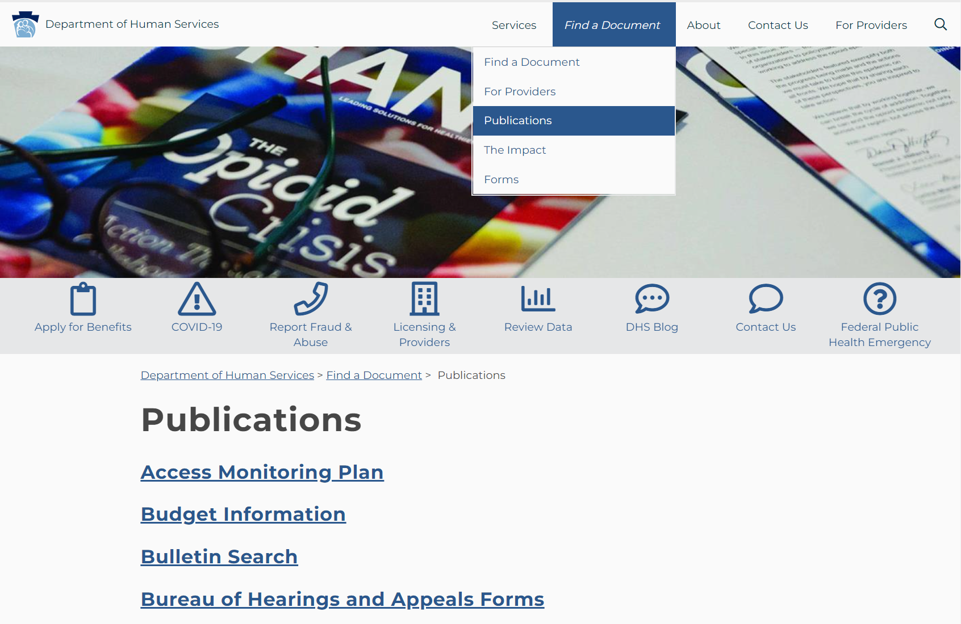
2
1

Bulletin Search
https://www.dhs.pa.gov/docs/Publications/Pages/default.aspx
Bulletin Search can be accessed through the DHS Publications page.
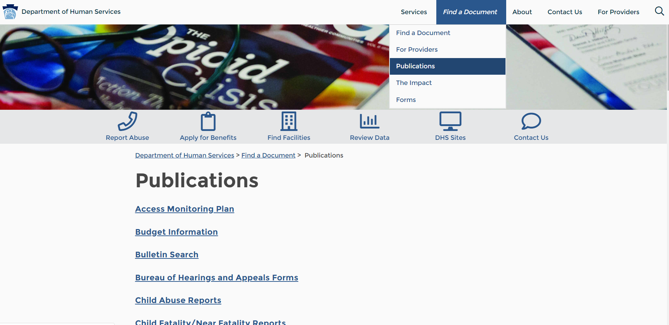
1
3
2
The Bulletin Search can also be accessed directly at:
https://www.dhs.pa.gov/docs/For-Providers/Pages/Bulletin-Search.aspx
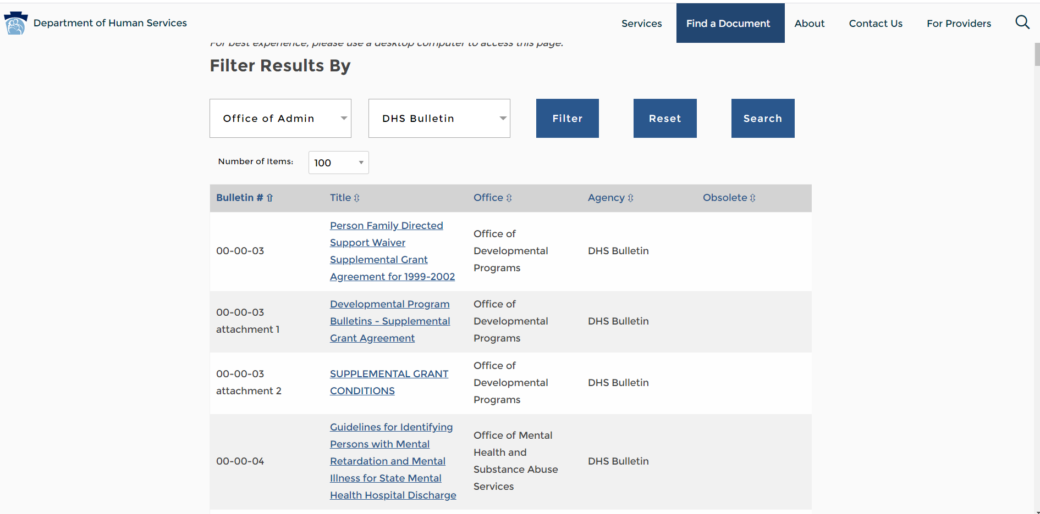

To make your bulletin search easier, follow these steps:
- In the first drop-down, choose the office(s) for which you want to find bulletins. A good choice for OLTL providers is the Office of Long-Term Living and Office of Medical Assistance Programs.
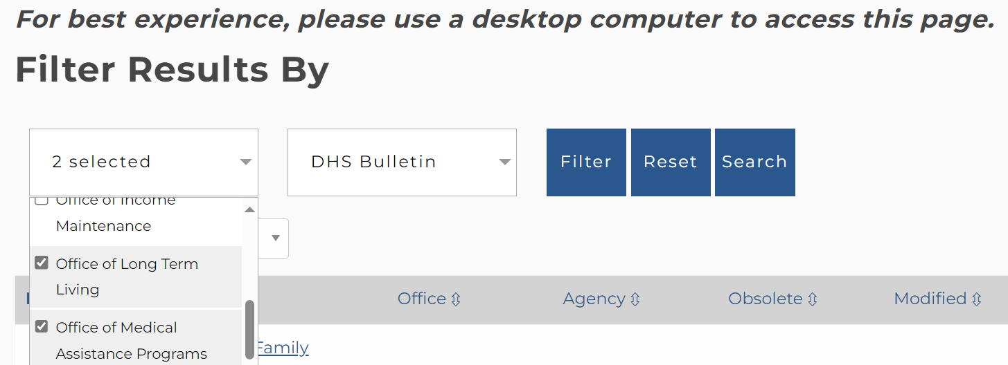
- Select Filter, which will bring up all bulletins for the office(s) chosen.
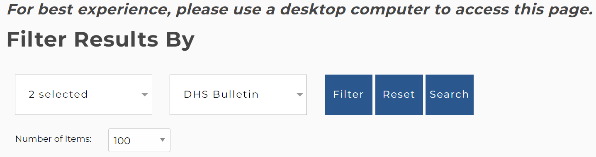
- Under Number of Items, choose “All” to bring up all bulletins for the office(s) chosen.
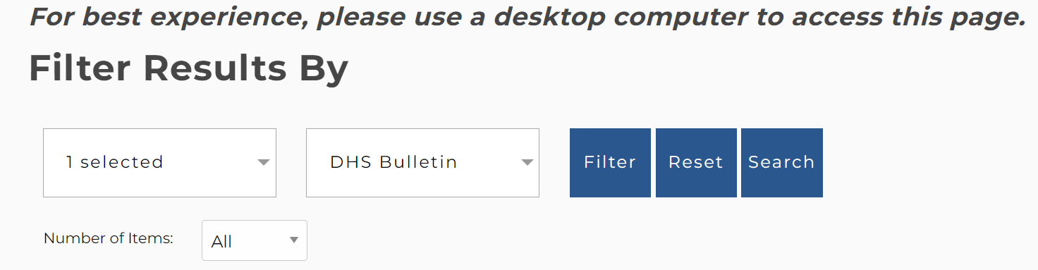

- Use the find function (ctrl + F) to search for the term you’re looking for:
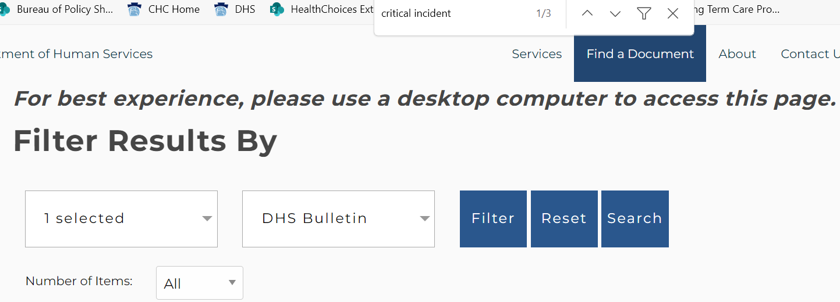

Service Plan Bulletin
https://www.dhs.pa.gov/docs/For-Providers/Pages/Bulletin-Search.aspx
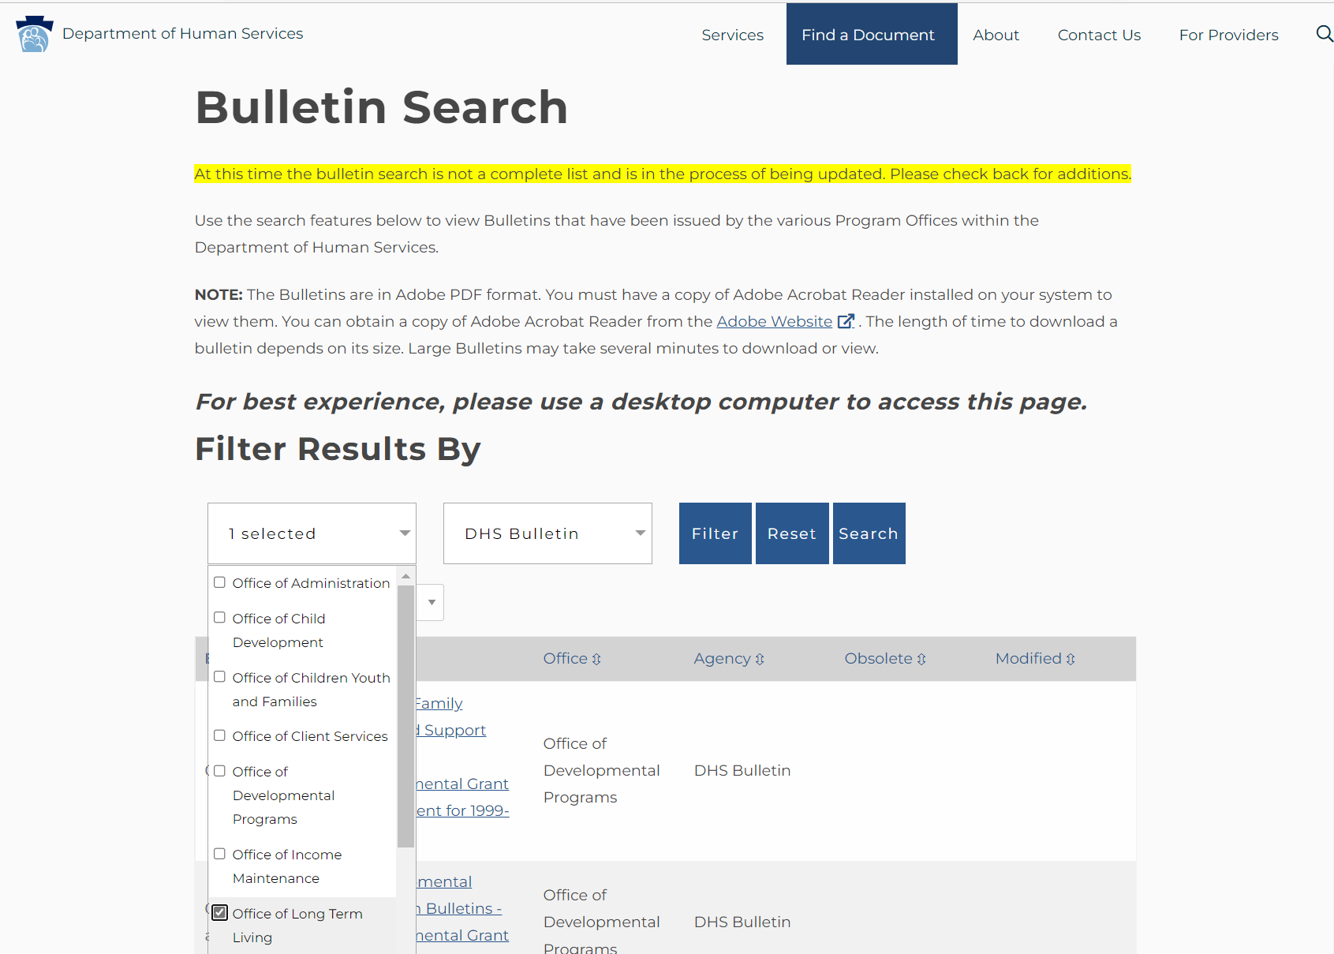
2
1
Service Plan

Participant Information Packet
www.dhs.pa.gov/Services/Disabilities-Aging/Documents/Long-Term%20Care%20Services/Participant%20Information%20Packet.PDF
The Participant Information Packet is available in several languages on the Long-Term Care Services webpage.
https://www.dhs.pa.gov/Services/Disabilities-Aging/Pages/Long-Term-Care-Services.aspx
