Nursing Home Transition (NHT) Resources

Table of Contents
Program Overview Module 1
NHT and Money Follows the Person (MFP) Eligibility Resources 1
Transition Planning Resources 1
Community HealthChoices (CHC) – Transportation 1
Housing Module 2
Section 811 Project Rental Assistance (PRA) Program 2
Home Maintenance Deduction Resources 2
Pennsylvania Caregiver Support Program / Family Caregiver Support Program (FCSP) 2
NHT Program for Providers Website 3
General Resource Links 4
Elder Resources 5
Resources for People with Disabilities 5
Emergency Preparedness and Recovery 6
Employment Resources 6
Housing Resources 7
Other Resources 8

Program Overview Module

NHT and Money Follows the Person (MFP) Eligibility Resources
Home and Community-Based Services (HCBS) Eligibility Form (PA-1768)
http://services.dpw.state.pa.us/oimpolicymanuals/ltc/PA_1768-Revised_Home_and_Community-Based_Service_(HCBS)_EligibilityIneligibilityChange_Form_(PA_1768).pdf
NHT Guidebook
www.dhs.pa.gov/providers/Providers/Documents/NHT%20Providers/NHT%20Guidebook.pdf

Transition Planning Resources
NHT Helpline: 1-800-833-5196
Email: Ra-pwnhtinfo@pa.gov
State NHT Team contact information:
- Rachel Sink (Primary contact), phone: 717-783-7378
- Brandy Green, phone: 717-783-7219

Community HealthChoices (CHC) – Transportation
CHC Transportation Fact Sheet
www.dhs.pa.gov/HealthChoices/HC-Services/Documents/Transportation.pdf

Housing Module

Section 811 Project Rental Assistance (PRA) Program
www.hudexchange.info/programs/811-pra/
SDHP is the statewide waitlist administrator for the 811 Project Rental Assistance Program (email: sdhp811@inglis.org) and provides training and technical assistance to service providers wishing to refer their participants to the program.

Home Maintenance Deduction Resources
www.dhs.pa.gov/providers/Providers/Documents/NHT%20Providers/Home%20Maintenance%20Deduction.pdf

Pennsylvania Caregiver Support Program / Family Caregiver Support Program (FCSP)
https://www.aging.pa.gov/aging-services/caregiver-support/Pages/default.aspx

NHT Program for Providers Website
www.dhs.pa.gov/providers/Providers/Pages/NHT-Providers.aspx
or:
1
2

3

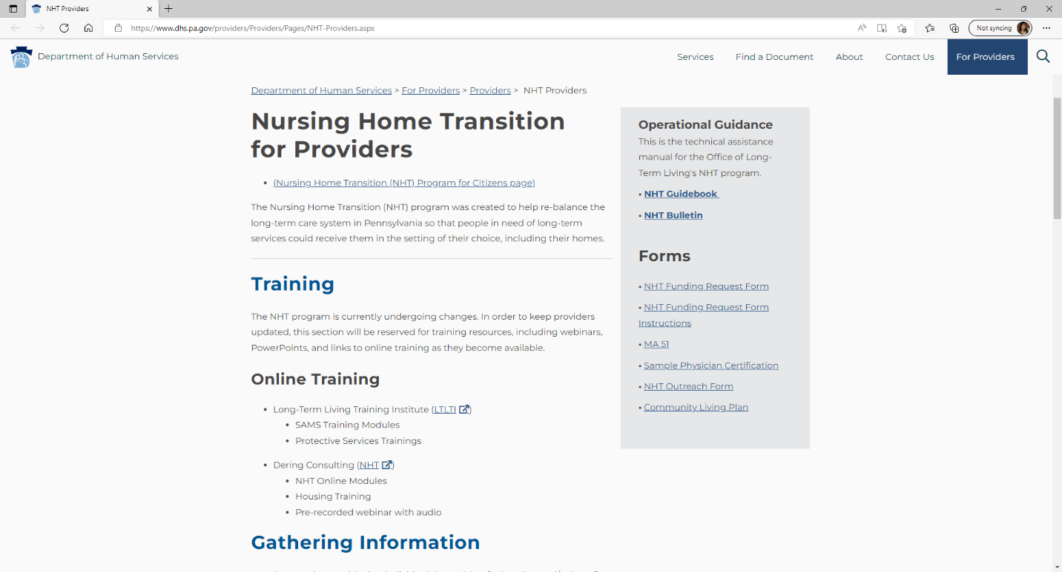

General Resource Links
Aging and Disability Resource Center (PA LINK to Resources)
www.aging.pa.gov/local-resources/pa-link/Pages/default.aspx#.VyD5CHrD8kI
American Public Transportation Association
www.apta.com
Commonwealth of Pennsylvania Website
www.pa.gov
COMPASS (apply for benefits provided by human services programs)
www.compass.state.pa.us/Compass.Web/public/cmphome
Department of Human Services
www.dhs.pa.gov
NHT Program for Citizens
www.dhs.pa.gov/Services/Disabilities-Aging/Pages/Nursing%20Home%20Transition.aspx
Pennsylvania Department of Education
www.education.pa.gov
Pennsylvania Housing Finance Agency (PHFA) Homeownership Programs
www.phfa.org/homeowners
PHFA Housing Services
www.phfa.org/mhp/serviceprovider
Pennsylvania Public Transportation Association
www.ppta.net/index.html
Property Tax/Rent Rebate Program
www.revenue.pa.gov/IncentivesCreditsPrograms/PropertyTaxRentRebateProgram/Pages/default.aspx
Social Security Administration
www.ssa.gov

Elder Resources
Pennsylvania Association of Area Agencies on Aging (P4A)
www.p4a.org
Pennsylvania Department of Aging
www.aging.pa.gov

Resources for People with Disabilities
Americans with Disabilities Act (ADA) - ADA Technical Assistance Centers
www.ada.gov
Autism – Paula Kluth’s Inclusion Rules
www.inclusionrules.com
National Association of the Deaf
www.nad.org
National Family Association for Deaf-Blind - Welcome
www.nfadb.org/
National Federation of the Blind
www.nfb.org
USA.gov – Federal government website for information on nationwide disability programs and services
www.usa.gov/disability-services
Disability Rights Pennsylvania
www.disabilityrightspa.org/
Harrisburg – 800-692-7443 (877-375-7139 TDD)
Philadelphia – 215-238-8070
Pittsburgh – 412-391-5225
Intellectual Disabilities Services
www.dhs.pa.gov/Services/Disabilities-Aging/Pages/Intellectual-Disabilities-Services.aspx
PA Council on Independent Living (PCIL)
www.thepcil.org
About PCIL - PCIL (thepcil.org)
www.thepcil.org/about-pcil/
Severe Communication Disorders – Communication matrix for parents and professionals
www.communicationmatrix.org/
World Institute on Disability
www.wid.org/

Emergency Preparedness and Recovery
American Red Cross
www.redcross.org
Disaster Assistance
www.disasterassistance.gov
Federal Emergency Management Agency
www.fema.gov
Pennsylvania Emergency Management Agency
www.pema.pa.gov

Employment Resources
Job Search – PA CareerLink
www.pacareerlink.pa.gov/jponline/
PA Department of Labor and Industry – PA Office of Vocational Rehab (OVR)
www.dli.pa.gov/Individuals/Disability-Services/ovr/Pages/default.aspx
PA Medical Assistance for Workers with Disabilities
www.dhs.pa.gov/Services/Assistance/Pages/MA-for-Disabled-Workers.aspx
Work Incentives Planning and Assistance
www.ssa.gov/work/WIPA.html

Housing Resources
Housing Alliance of Pennsylvania
www.housingalliancepa.org/
Local Housing Options Teams (LHOTs)
Currently, LHOT information is provided on the internet through several county-related websites. Doing an internet search will locate some of these resources. If a more centralized website is developed, we will update this document.
PA Assistive Technology Foundation
www.patf.us/
Community Action Association of Pennsylvania
www.thecaap.org/
PA Housing Finance Agency
www.phfa.org/
PA Housing Search
www.pahousingsearch.com
PA Residential Owners Association (PROA)
www.proassoc.org/cgi-bin/PROAOrgs.pl
Regional Housing Coordinator Program (RHCP) – Information & Referral Request
www.inglis.org/programs-and-services/inglis-community-services/self-determination-housing-of-pennsylvania-sdhp/regional-housing-coordinator-program/information-and-referral-request
Self-Determination Housing of Pennsylvania (SDHP)
www.inglis.org/programs-and-services/inglis-community-services/self-determination-housing-of-pennsylvania-sdhp
US Department of Agriculture
www.usda.gov
US Department of Housing and Urban Development (HUD)
www.hud.gov
HUD Exchange
www.hudexchange.info/
US Department of Veterans Affairs (VA)
www.va.gov
US Internal Revenue Service – Tax Highlights for Persons With Disabilities
www.irs.gov/publications/p907
PA Low-Income Home Energy Assistance Program (LIHEAP)
www.dhs.pa.gov/Services/Assistance/Pages/LIHEAP.aspx
Pennsylvania Association of Housing and Redevelopment Agencies (PAHRA)
www.pahra.org/

Other Resources
Annual Credit Report
www.annualcreditreport.com
Commission on Accreditation of Rehabilitation Facilities (CARF)
www.carf.org/home/
Consumer Credit Counseling Services (CCCS)
www.credit.org/cccs
Federal Trade Commission – Spam
www.consumer.ftc.gov/articles/0038-spam
Government Mortgage Help
https://home.treasury.gov/data/troubled-assets-relief-program/housing
Help in PA – Resources for Your Family's Health
www.health.pa.gov/topics/programs/Pages/Help-in-PA.aspx
The Joint Commission
www.jointcommission.org/
National Center for Cultural Competence
https://nccc.georgetown.edu/
National “Do Not Call” Registry
www.donotcall.gov/
U.S. Access Board – Advancing Full Access and Inclusion for All
www.access-board.gov/
Obtaining a Photo Identification Card
www.dmv.pa.gov/Driver-Services/Photo-ID2/Pages/Get%20An%20ID.aspx
Pennsylvania ABLE Savings Program (PA ABLE)
www.paable.gov/benefits/?utm_medium=search&utm_source=google&utm_campaign=pa_able&utm_content=fy21
Pacer Center ADA Q&A
https://www.pacer.org/transition/learning-center/laws/ada/health-care-providers.asp
PA Attorney General Office
www.attorneygeneral.gov/
PA Department of Aging Ombudsman
www.aging.pa.gov/organization/advocacy-and-protection/Pages/Ombudsman.aspx
PA Department of Labor and Industry
www.dli.pa.gov
Pennsylvania Advocacy and Resources for Autism and Intellectual Disability
www.par.net/
Social Security Card Application
www.ssa.gov/online/ss-5fs.pdf
Request Military Service Records (DD Form 214)
www.archives.gov/veterans/military-service-records/
Veteran’s Benefits and Outreach
www.va.gov

